sDS 522 Data Acquisition and Analytics
HOS05A – Reading and Writing Data in Pandas
08/18/2024 Developed by Catherine Ata
10/16/2025 Reviewed by Ashwin Paturi
2/14/2026 Revised by Jonathan Koerber
04/08/2026 Reviewed by Vishal Krishna Kumar

School of Technology & Computing (STC) @ City University of Seattle (CityU)
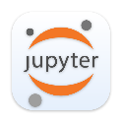
Take Note Before Starting
- The directory path shown in the screenshots may differ from your actual directory.
- Not every step is explained in the tutorial. If you are not sure what to do:
  - Consult the resources listed below.
  - If you cannot solve the problem after a few tries, email your course TA for help.

Learning Outcomes
- Learn how to read and write data from and into a CSV file format using Pandas.
- Learn how to read and write data from and into a JSON file format using Pandas.
- Learn how to read and write data from and into an HTML file format using Pandas.
- Learn how to read and write data from and into an XLXS file format using Pandas.
- Learn how to read and write data from and into a database using Pandas.

Resources:
- McKinney. (2022). Python for Data Analysis (3rd edition).
- IO tools (text, CSV, HDF5, …). (2024.). Pandas. https://pandas.pydata.org/pandas-docs/stable/user_guide/io.html

Getting Started
- Open the VS Code and, within the VS Code, open the DS522 course folder created earlier. On the menu tab, select File, then Open New Folder. Navigate to your work directory or GitHub repository that you have cloned. Example: C:\ Desktop\DS522 OR C: \Desktop\DS522\github_repository_name
Incorporating AI into your Learning Workflow
In this course, we embrace the future of development. Tools like GitHub Copilot, Gemini,
and ChatGPT are integrated into modern environments like GitHub Codespaces and VS Code. Our goal is to use these tools not as "answer engines," but as Socratic Tutors. Answer challenge questions by consulting AI tools.
Use AI as a Socratic Tutor to answer the challenge questions throughout this doc and save
your responses in a separate document.

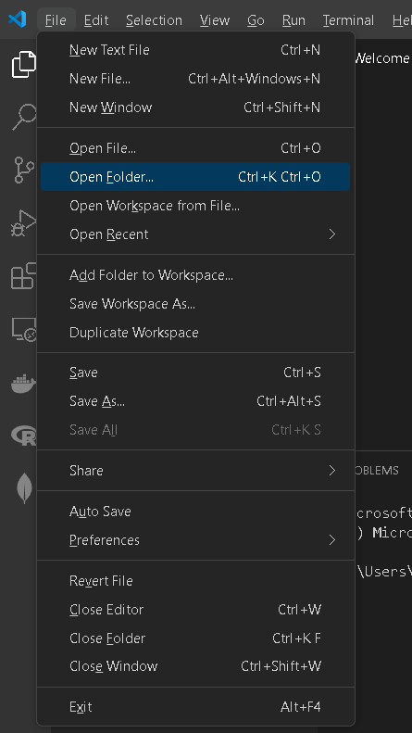

NOTE: If you have cloned a GitHub repository that is provided specifically for this course, navigate to that directory, and skip steps 2 to 4. This will be the folder where you will be storing all your HOS05A work.

- Once in your work directory, go to the menu tab again, select Terminal, select New Terminal to open a Command Line Interface (CLI) like the Command Prompt or PowerShell for Windows OS.
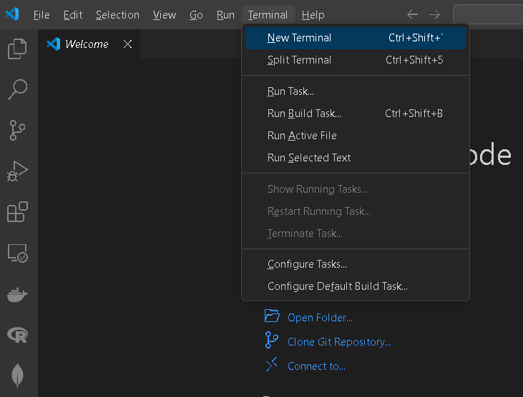

- Inside your “DS522” directory, create a new directory and name it “HOS05A”. Use the following command: >mkdir HOS05A
- Move to the new directory. Use the following command: >cd HOS05A

NOTE: This will be the folder where you will be storing all your HOS05A work.

Read and Write
Pandas is a powerful and popular framework for data analysis and manipulation. One of the most valuable features of Pandas is the ability to read and write various file types, including CSV files. Pandas provide the I/O API, which “is a set of top-level reader functions accessed like pd.read_csv() that returns a pandas object” (IO, n.d.).

These methods cover the most common data formats you will encounter when working with Pandas.
- CSV: Use pd.read_csv() to load and df.to_csv() to save.
- Excel: Use pd.read_excel() to load and df.to_excel() to save.
- JSON: Use pd.read_json() to load and df.to_json() to save.
- HTML: Use pd.read_html() to load and df.to_html() to save.
- SQL: Use pd.read_sql_query() to load and df.to_sql() to save.
- Pickle: Use pd.read_pickle() to load and df.to_pickle() to save.

Reading and Writing CSV Files
- In your HOS05A folder or HOS5A repository, create a New File by clicking File on the top menu bar, then New File, and select the Jupyter Notebook option. Save the file with Ctrl + S and rename it to reading_writing.ipynb.
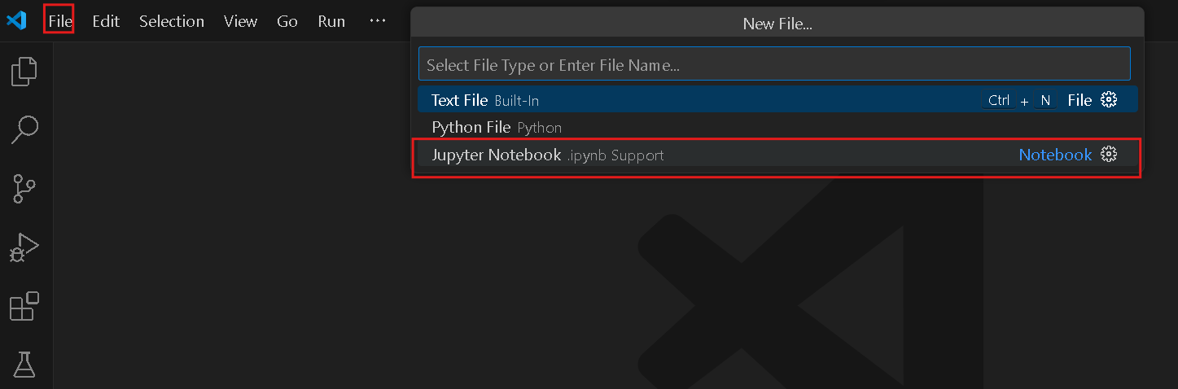
2. Type the following code and run the code cells to see the output:

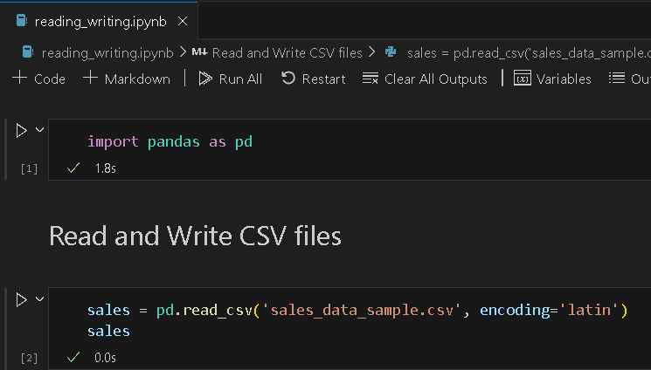

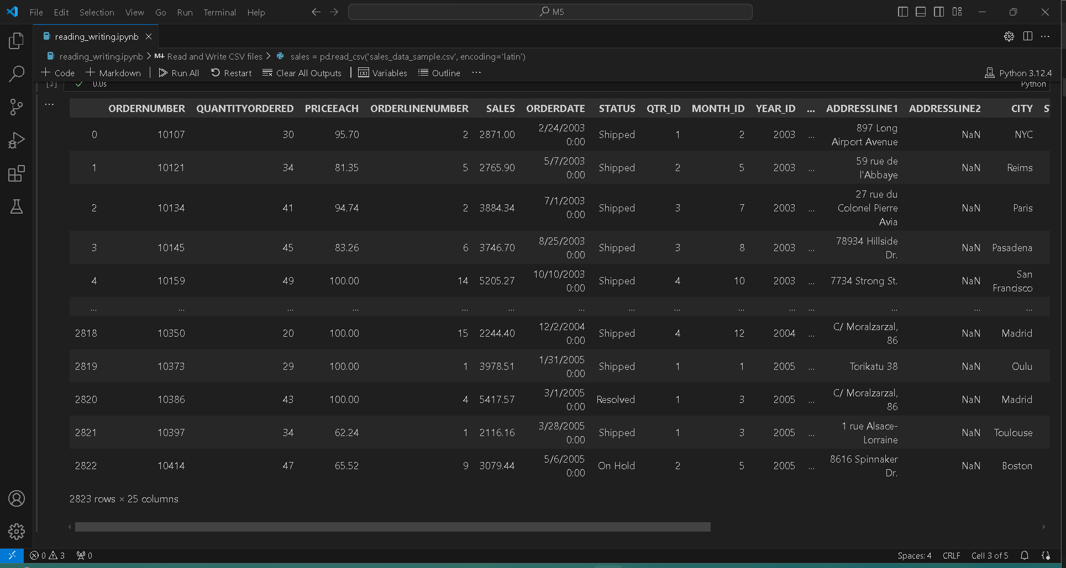

‘latin-1’ and ‘iso-8859-1’ are the simplest text encoding maps. They map the code points 0-
255 to the bytes 0x0-0xff, which means that a string object containing code points above U+00ff cannot be encoded with this codec. Trying to do so will raise a UnicodeEncodeError.

  - The sales dataset has 25 columns. To list all columns, type the following code in a new code cell and run it to see the output:
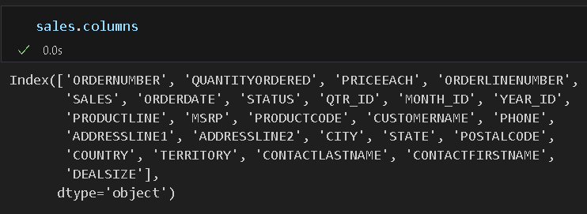

  - There will be times, especially when you are doing analysis, when you do not need all the columns, or you only need a sample set of the data. You can write a subset of the data into a new CSV file by selecting a list of column names with the indexing operator and the .to_csv() method. Type the following code in a new code cell and run.

This will create a new_sales.csv file and save it in your current working directory.
The Series and DataFrame objects have an instance method to_csv, which allows storing the contents of the object into a comma-separated-values file. It is important to note that there are a couple of standard exceptions that arise when doing selections with just the indexing operator:
• If you misspell a word, you will get a KeyError.
• If you forgot to use a list to contain multiple columns, you would also get a KeyError.

  - In your working directory, navigate to the new_sales.csv file and open it. It should look like the sample below.

Challenge: Explain why the transition from manual data entry to loading CSV files via
pd.read_csv() is a pivotal moment in learning Python for Data Science. What are the three
specific 'automatic' features Pandas perform when reading a CSV that would take dozens of
lines of code in standard Python? Why is this considered the gateway to working with 'Big
Data ?

pd.read_csv() replaces dozens of lines of manual parsing, raw Python forces you to handle headers, type casting, and delimiter edge cases yourself, while Pandas silently automates all three.
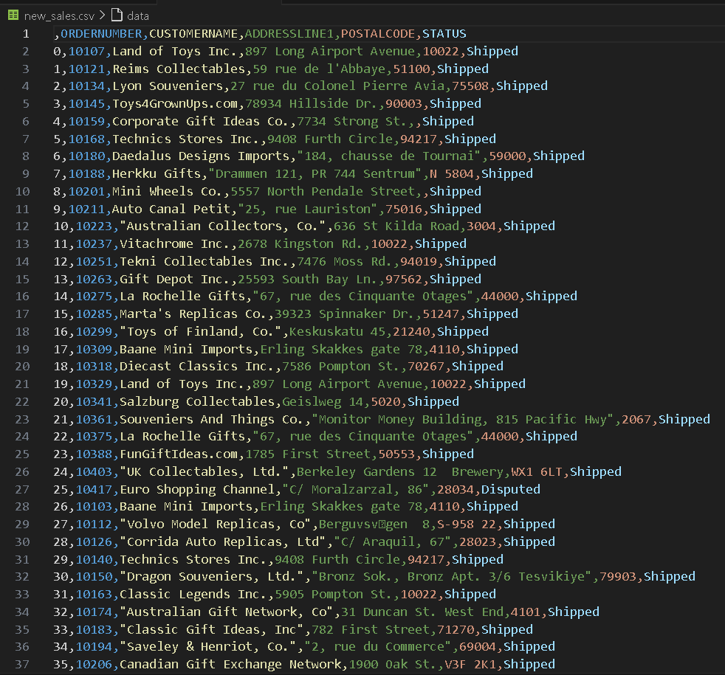

Loading and Saving Excel Files

- To read Excel files with Pandas, we need to install an external module called openpyxl, which is not included with the standard Python distribution. Type the command below in a code cell. Run the code below to install the necessary module.
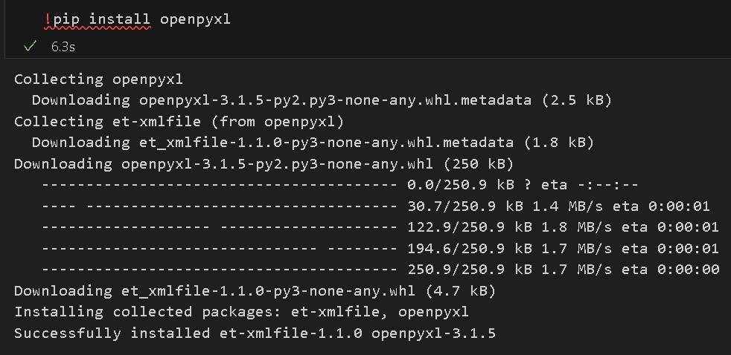

- Open a new cell and type the following code. We will load and read an Excel file using the pd.read_excel() function. Run the code cell to see the output.

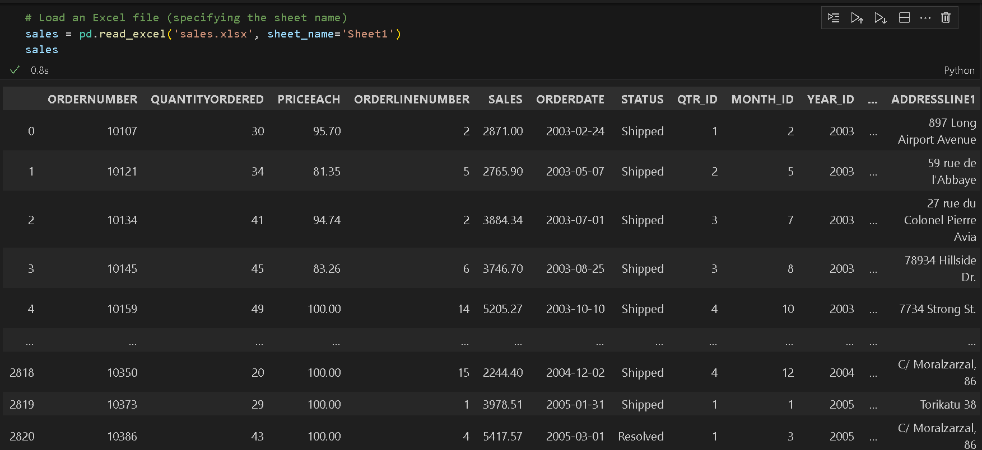

- If we want to list all the products available, we can create a subset of the data frame that would only contain all the columns that are related to the products. Type the following code and run to see the output.
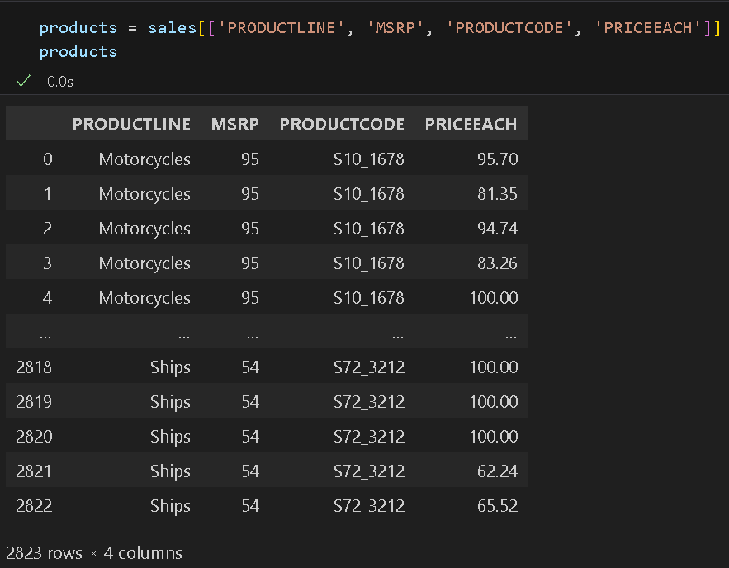
- Let us save our new data frame into a new Excel file by using the to_excel() method. Type the following code in a new code cell, then run.

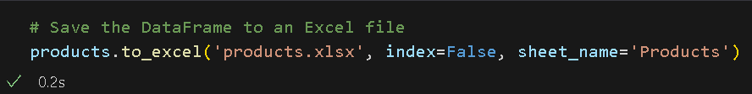

- Expect a products.xlsx file to be created and saved to your current directory. Open the file to verify that it contains the correct information.
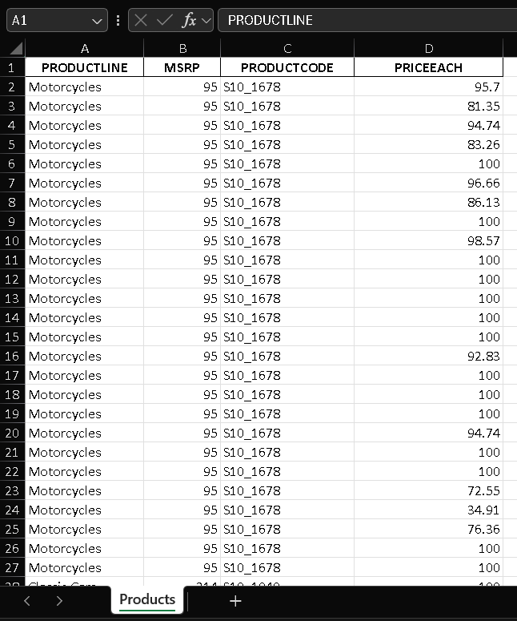

Reading and Writing JSON Files
- In the same notebook, open a new cell and type the following code. We will load and read a JSON file using the pd.read_json() function. Run the code cell to see the output.

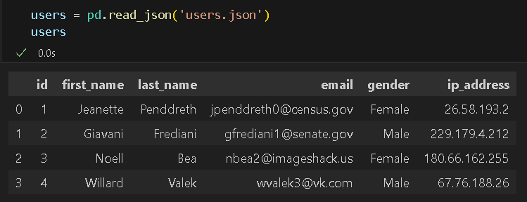

- Let us create a nested list containing dictionaries as elements. We will then convert this into a data frame and add the entries to the existing data frame of users. Type the following code into a new cell. Run the code and see the output.

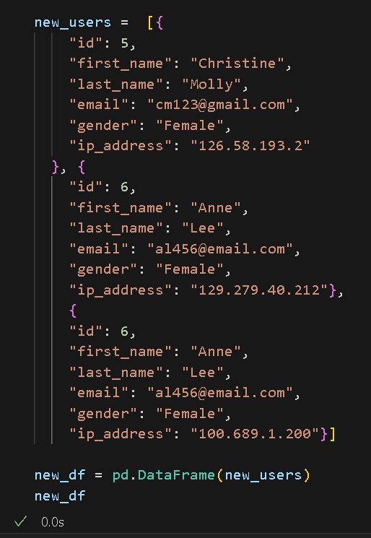

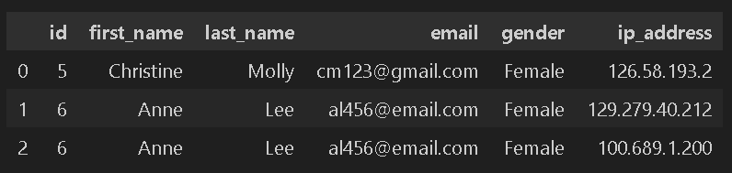

- Now, let us create a new data frame by concatenating the user’s data frame and the new_df. Again, type the following code in a new code cell and run it to see the growing data frame.
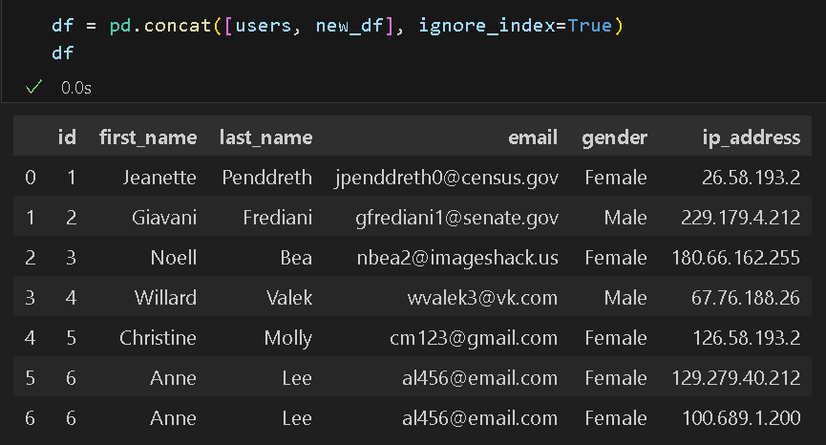

- Let us save our new data frame into a new JSON file by using the to_json() method. Type the following code in a new code cell, then run.

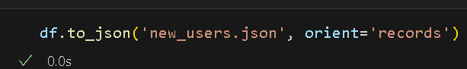

- Expect a new_users JSON file to be created and saved to your current directory. Open the JSON file to verify that it contains the correct information.

NOTE: This is a snippet of the new_users.json; your output should look as follows:

Challenge: Analyze the fundamental differences between the tabular (Flat) structure of CSV and the hierarchical (Nested) structure of JSON. Explain how 'nesting' allows JSON to represent complex relationships that a CSV cannot easily capture.
A CSV is a flat table where every cell holds one value relationships require duplication or splitting into multiple tables. JSON solves this with nesting: a single record can contain entire objects or arrays within it, so a customer with three orders doesn't need three repeated rows the orders live inside the customer object. This mirrors how real-world data actually works users have addresses, orders have line items, line items have products and why JSON dominates APIs and document databases like MongoDB, where forcing that hierarchy into flat rows would be either lossy or absurdly redundant.

Reading and Writing HTML Files

- In the same notebook, open a new cell and type the following code. We will read an HTML file using pd.read_html(). Before using the read_html() function, you need to install lxml. It is an external module that is not included with the standard Python distribution. Run the code cell to see the output.
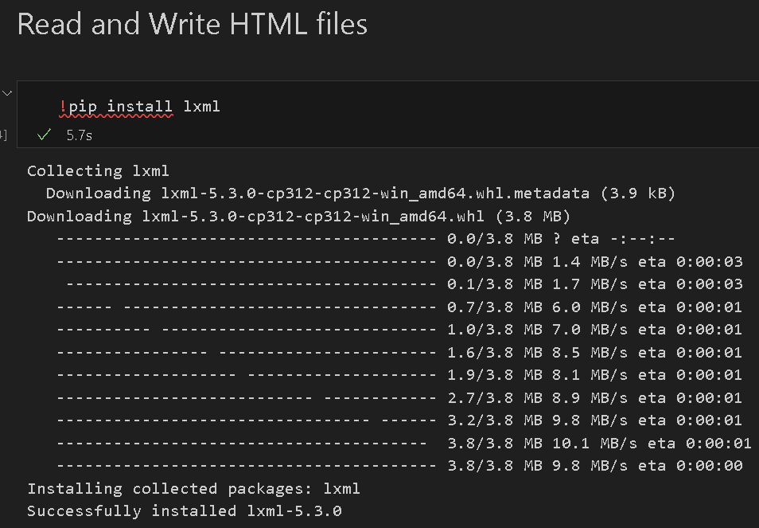
Once you have installed lxml, you can use read_html() to read in an HTML file as a list of
DataFrame objects. Each DataFrame is a table element from the HTML file.

- Type the following code to a new cell in your notebook. Run the cell to see the output. Take note that we passed the index 0 in this example. If you are reading a different HTML file, you might want to check the number of tables and try the different index numbers.

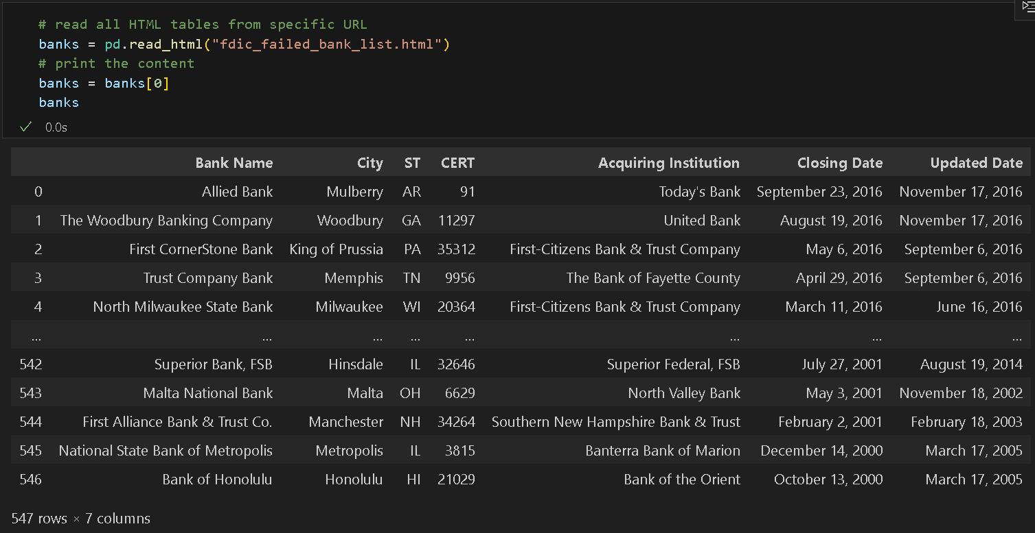

- Now let us edit the bank's data frame by converting the ‘Closing Date’ column into a datetime format, then save the conversion into a different column ‘Close Date’. Type the code below in a new cell and then run it. Take note of the last column in the data frame.

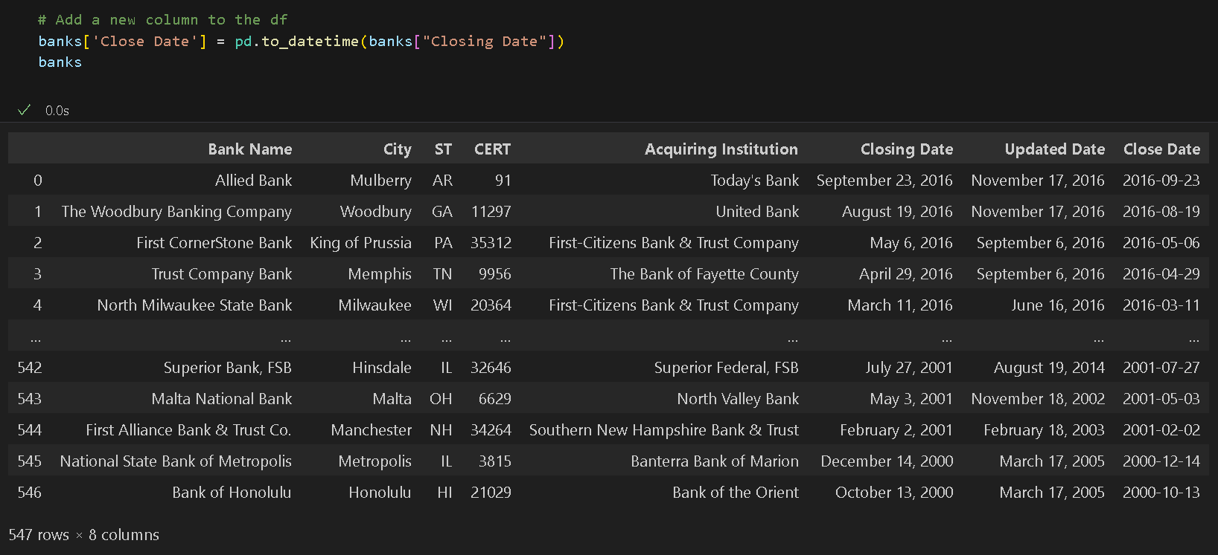

- We can also try to get some valuable information by counting the number of banks that close per year. Type the following code, then run to see the counts.

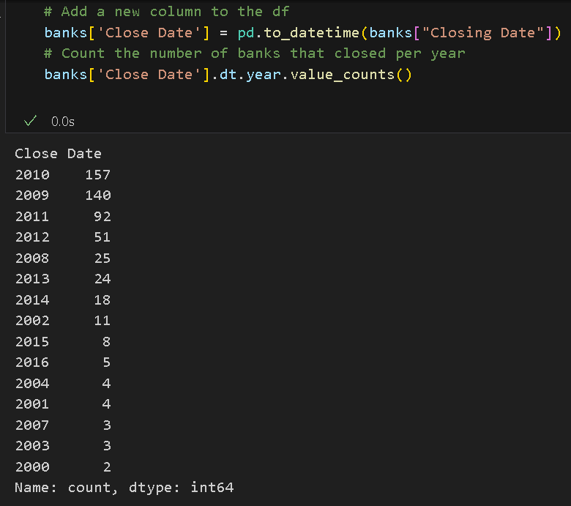
- Let us save the data frame as a new HTML file called banks.html. Again, open a new cell, then type the code below. Run, then check the newly created HTML file in your working directory.

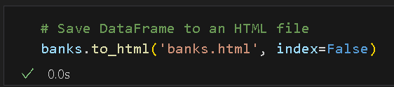

- Open the banks.html file in VS Code and see the tag hierarchy in an HTML file, which can vary per file. Below is a snippet of the banks.html that we just created:

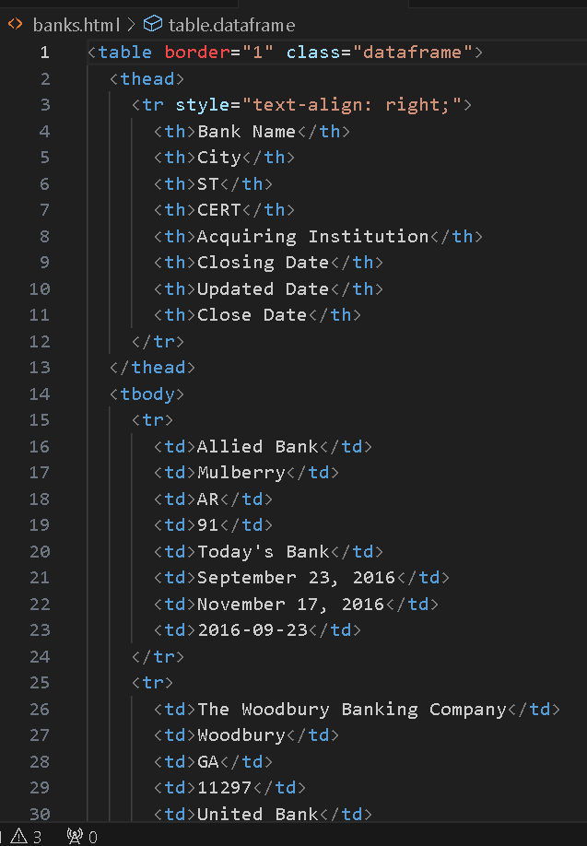

Loading and Saving SQLite Database
SQLite is a self-contained, high-reliability, embedded, full-featured, open-source relational database management system (RDBMS). It is widely used due to its simplicity, portability, and ease of integration. Because it is self-contained, SQLite does not require a separate server process or system to operate. All the database operations are managed within a single file, making it lightweight and easy to set up.

- To work in this environment, first, you will create an SQLite database and a table to store our data. Type the code below in a new cell in the same reading_writing.ipynb notebook. Run the code to create a new database.

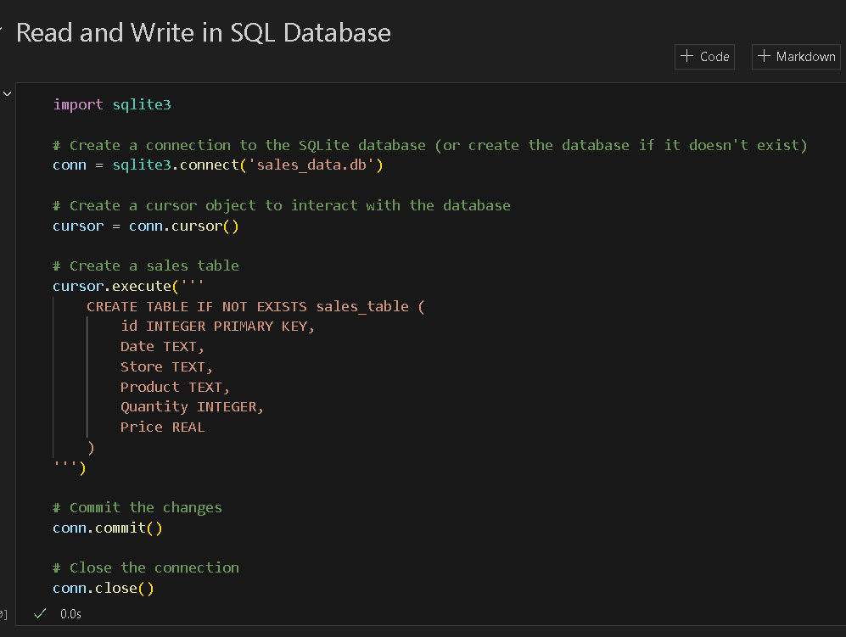

- Next, you will insert some sample data into the sales_table. Type the code below in a new cell. Run the code to add entries to your table.
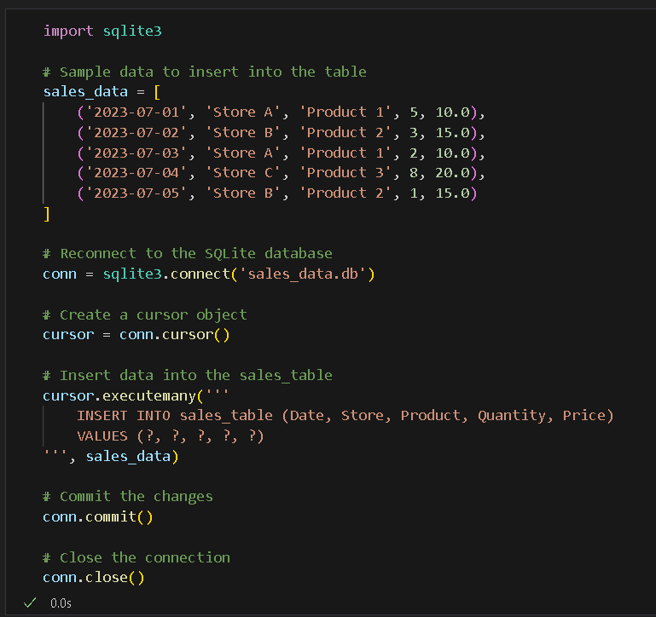

- Now, you can read the data from the SQLite database into Pandas DataFrame. Again, type the following code to a new cell then run to see the output.
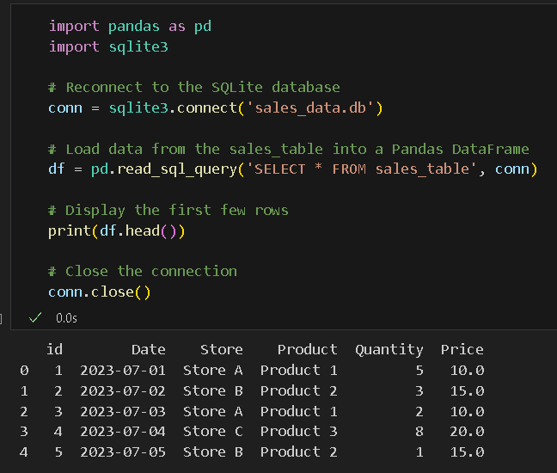
- Now that you have an SQLite database, you can write data from a pandas data frame to your database by using the to_sql() method.

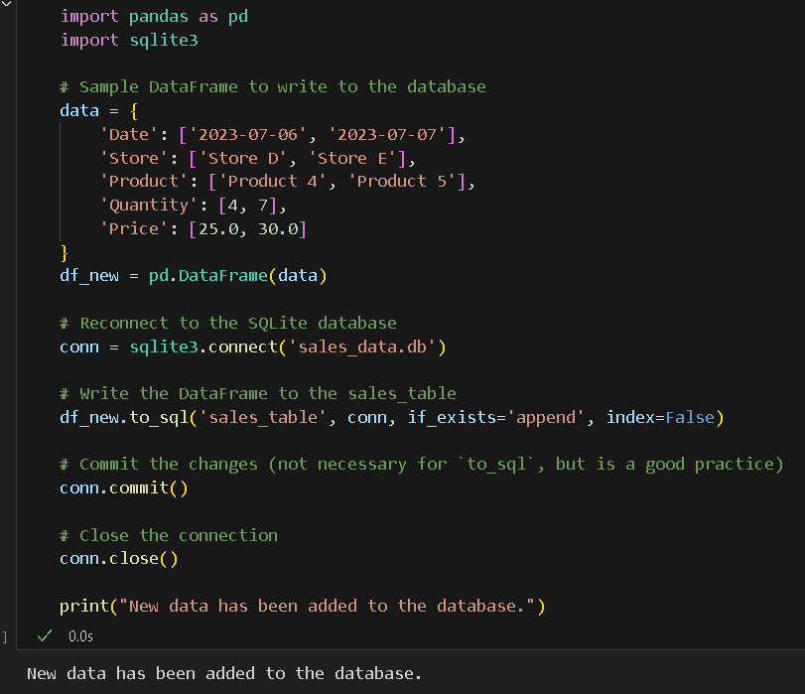

- To verify that the data has been successfully written, you can query the database and display the results again. Open a new code cell, then type the code below. Run to see the output.

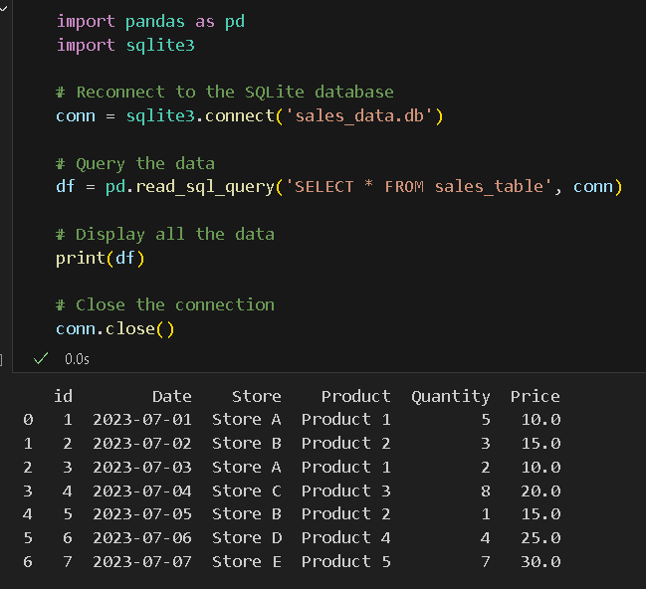
Challenge: Explain the architectural advantages of SQLite's for local data analysis.
SQLite's key advantage is being serverless, the entire database is a single .db file requiring zero configuration, so you get full SQL power (joins, aggregations, indexing) without installing or running anything. It also handles datasets too large for RAM by querying directly from disk, meaning you pull only what you need into Pandas rather than loading everything at once. It's the perfect middle ground between a flat CSV and a full production database.

*** This is the end of the HOS5A exercise. Please answer HOS05B in Brightspace after pushing your work to GitHub. ***

Push your work to GitHub: Follow the instructions on the CityU STC TA Center Github.io Submit your work page
You may also follow the instructions below:
1. Open the cmd terminal for Windows users,
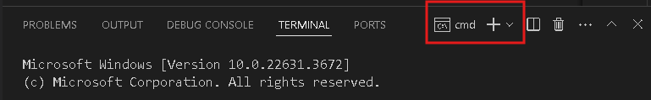

- After selecting the + button, make sure the terminal is cmd if you have not closed the Python terminal. If the terminal is not cmd, you need to add it by opening the drop-down box and selecting the "Select Default Profile" option.

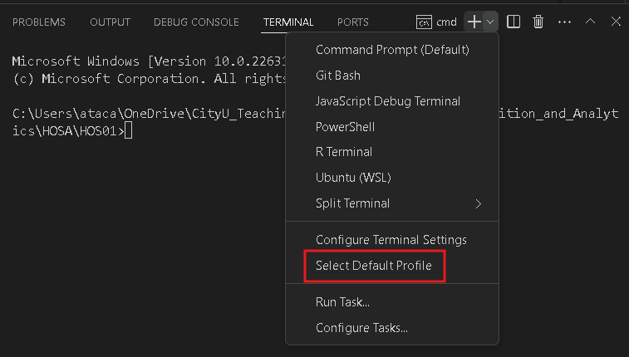

Look for and then select Command Prompt
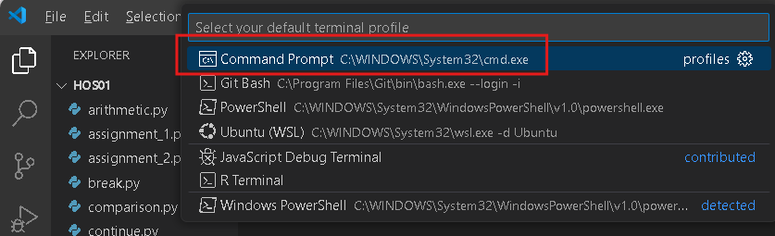

Click the + button. The command prompt will open.

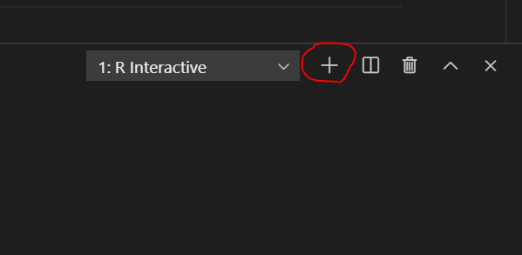

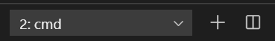

- Make sure you are in the correct directory/repository: Desktop/DS522/hos04a-courseName-yourUserName
- Run the following commands to push your work to the GitHub repository:
- Open the terminal from VSCode by hitting the control + ~ key and type the following command:
>>> git add .
>>> git commit -m “Submission for HOS05A”
>>> git push

*** Please answer HOS05B in Brightspace. ***

